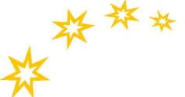
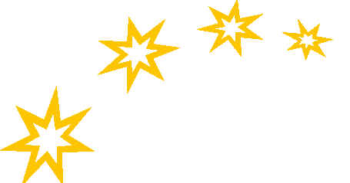
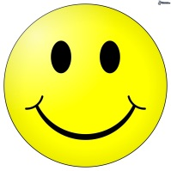 Night time Chart

Put a sticker on as you do it! How many stickers can you get?

Day | Set Table | Dinner | Bath | PJ’s | Teeth | Toilet | Drink | Book | Music | Light off
Monday
Tuesday
Wednesday
Thursday
Friday
Saturday
Sunday

Copyright Babysmiles www.babysmiles.com.au

